**HTML Question**

1.**Write the HTML5 code required to create a form that looks like the following screen design. Only write the FORM element and**

**Its contents** (5 marks)

(you do not need to include an entire web page, and you do not need to include any JavaScript in your solution).

•For the email field, make sure that the user can only enter a valid email address.

•The user can only select one day (either Friday, Saturday, or Sunday)

•The form elements are grouped together with the caption 'Options'

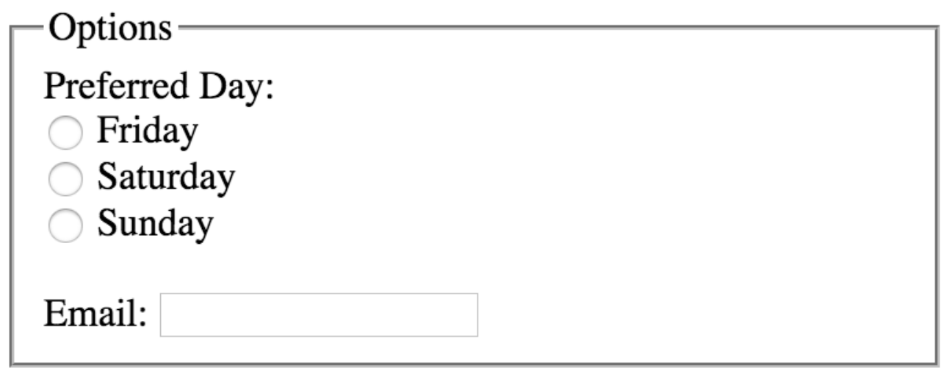

2. **Write the HTML5 code required to create a form that looks like the following screen design. Only write the FORM element and**

**Its contents**

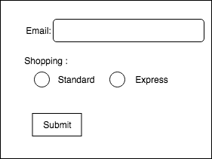

3.**Write the HTML5 code required to create a form that looks like the following screen design. Only write the FORM element and**

**Its contents**

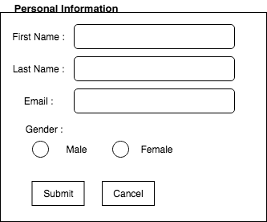

**4. Write the HTML5 code required to create a form that looks like the following screen design. Only write the FORM element and**

**Its contents**

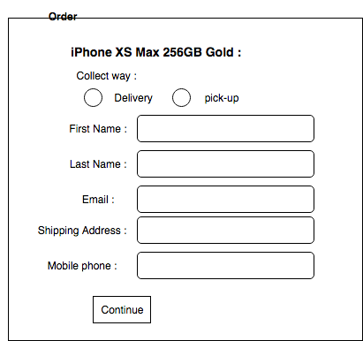

**CSS Section**

Question 1 (5 marks):

Write down the CSS style definition required to style the body so that it has:

1. a correct CSS selector
2. a 2em padding on all sides
3. a width of 80%
4. a font family set to Arial
5. a background image set to the file "sky.png"

Question 2 (5 marks):

Write down the CSS style definition required to style a class name which name is items

so that it has:

1. a correct CSS selector
2. a 20px margin on all sides
3. a width of 100%
4. a text color set to white
5. a background color set to blue

Question 3 (5 marks):

Write down the CSS style definition required to style h1 tag so that it has:

1. a correct CSS selector
2. a text color set to red
3. a font size set to 19px
4. a font family set to sans-serif
5. a border set to 1px and black color

Question 4 (5 marks):

Write down the CSS style definition required to style an ID named as active so that it has:

1. a correct CSS selector
2. a width of 500px
3. a height of 600px
4. a background image set to the file “cat.png”
5. a border set to 3px and black color

Question 5 (5 marks):

Write down the CSS style definition required to style a p tag so that it has:

1. a correct CSS selector
2. a red text
3. a font size set to 1.5em
4. a font family set to Arial
5. a border set to 2px and black color

**JavaScript**

Q1. Complete the missing JavaScript code to make change the background color of a text field to yellow when the user clicks on the text field.

Here is the partially completed code (some code has been omitted as indicated by the ellipses "..."). The space marked with the arrow is where the missing JavaScript belongs. Write the missing JavaScript on the next page.

<!doctype html>

<html>

<head>

<meta charset="utf-8" />

<title> </title>

<script>

... 🡨-------

</script>

<style></style>

</head>

<body>

<input type="text" id="myfield" onclick="highlight()"/>

</body>

</html>

Q2. Complete the missing JavaScript code to make change the text color of a text field to blue when the user clicks on the text field.

Here is the partially completed code (some code has been omitted as indicated by the ellipses "..."). The space marked with the arrow is where the missing JavaScript belongs. Write the missing JavaScript on the next page.

<!doctype html>

<html>

<head>

<meta charset="utf-8" />

<title> </title>

<script>

... 🡨-------

</script>

<style></style>

</head>

<body>

<input type="text" id="textField" onclick="input_Clicked()"/>

</body>

</html>

Q3. Complete the missing JavaScript code to make change the text color of a text field to blue when the user clicks on the text field.

Here is the partially completed code (some code has been omitted as indicated by the ellipses "..."). The space marked with the arrow is where the missing JavaScript belongs. Write the missing JavaScript on the next page.

<!doctype html>

<html>

<head>

<meta charset="utf-8" />

<title> </title>

<script>

... 🡨-------

</script>

<style></style>

</head>

<body>

<input type="text" id="inputField" onclick="isClicked()"/>

</body>

</html>

Q4. Complete the missing JavaScript code to make change the text color of a paragraph to red when the user clicks on the button.

Here is the partially completed code (some code has been omitted as indicated by the ellipses "..."). The space marked with the arrow is where the missing JavaScript belongs. Write the missing JavaScript on the next page.

<!doctype html>

<html>

<head>

<meta charset="utf-8" />

<title> </title>

<script>

... 🡨-------

</script>

<style></style>

</head>

<body>

<p id=”message”> Hello World!!!</p>

<button onclick="makeRed ()">Click Me</button>

</body>

</html>